Recruiting for the following positions:
Housekeeping Security Officers
Landscaping

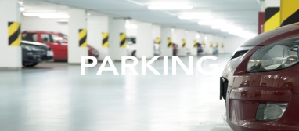
Parking Lot Attendant Shuttle Drivers
CDL Drivers: Class A, Class B, and Class C

If you are interested in any of the above position(s), please forward resumes to denise.bice@maryland.gov.

Expiration Date: 11/10/2017

