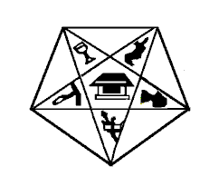
Myra Grand Chapter
Order of the Eastern Star, P.H.A.
State of Maryland and Jurisdiction

CHANGE OF NAME/ADDRESS FORM

Date:

TO: Myra Grand Chapter, 0.E.S P.H.A. 1307 Eutaw Place
Baltimore, MD 21217

MEMBER NAME:

Chapter Name: |  | Chapter No.
(Chapter Name)

NAME CHANGE: Submit documentation (Copy of marriage certificate, Court documents, etc.)

NAME CHANGED TO:

Change the Address to:

Thank you for your prompt attention to this matter.

Fraternally Submitted, Chapter seal

__________________________________________________
(Signature of Secretary)

