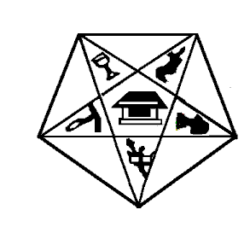
Myra Grand Chapter
Order of the Eastern Star, Prince Hall Affiliated
Maryland and Jurisdiction

CERTIFICATE FOR ONE DROPPED FROM THE
ROLL AT OWN REQUEST

To Whom It May Concern,

Greetings:

This is to certify that __________ ______________________________________________, a member of

___________________________________________________ Chapter No. ___________, located at

______________________________________________________ State of________________ __________,
having paid all her (his) indebtness was dropped from the roll of this Chapter on

__________ day of ___________________________, 20 _________, at her (his) own request.

Given under our hands and Seals of the Chapter at ___________________________________________ this __________ day of _______________________, 20__________.

(Seal)

___________________________________________ Worthy Matron
(Original signature)

____________________________________________ Worthy Patron

Attest

_________________________________________________ Secretary
(Original Signature)

